How can I run a WMI query outside of ADDM?
ADDM publishes the WMI queries it uses in discovery. See Administration > Platforms > WMI support. How can I run these queries outside of ADDM?
From the Windows proxy do Start > Run > wbemtest. You’ll get a screen that looks like this:
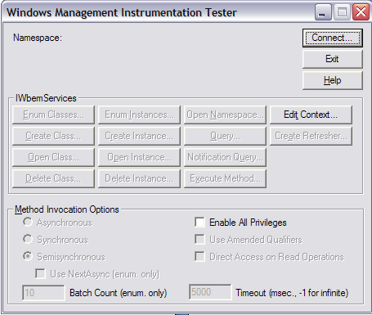

Click Connect and enter the connection information as follows (substitute your ip address and login info):
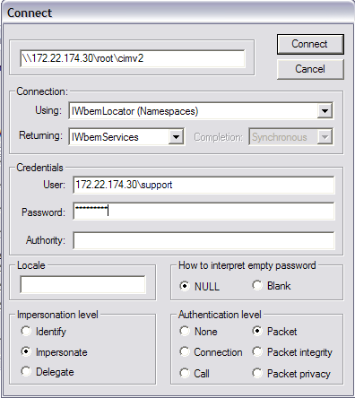

Then click Connect again and you’ll get this screen:
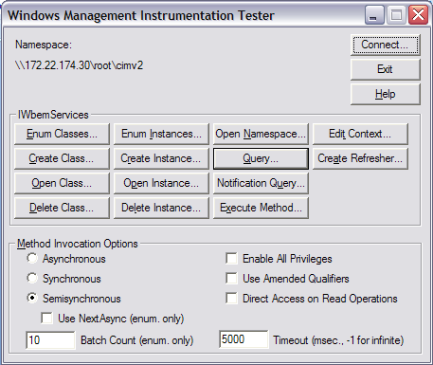
Select the Query button and enter the query, for example “SELECT * FROM Win32_Service”. Then run the query. You should get a result like this:
